# **Name: Abdurrahman Qureshi**

# **Roll No: 210451**

Practical No: 8

**1) Write a Program to create a first display screen of any search engine using AutoCompleteTextView.**

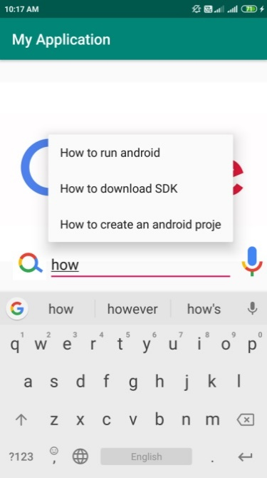 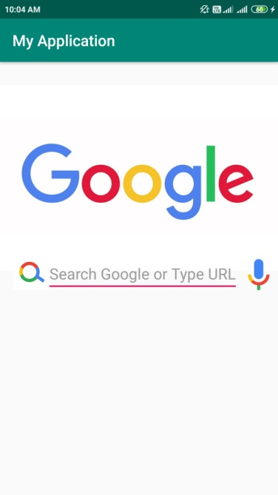

**XML CODE:**

<?xml version="1.0" encoding="utf-8"?>  
<LinearLayout  
 xmlns:tools="http://schemas.android.com/tools"  
 xmlns:android="http://schemas.android.com/apk/res/android"  
 xmlns:app="http://schemas.android.com/apk/res-auto"  
 android:layout_width="match_parent"  
 android:layout_height="match_parent"  
 tools:context=".MainActivity"  
 android:orientation="vertical"  
 >  
  
 <ImageView  
 android:layout_width="wrap_content"  
 android:layout_height="wrap_content"  
 android:layout_gravity="center"  
 android:src="@drawable/google_logo"/>  
  
 <AutoCompleteTextView  
 android:layout_width="300dp"  
 android:layout_gravity="center"  
 android:layout_height="wrap_content"  
 android:completionThreshold="1"  
 android:id="@+id/actv"  
 android:textSize="20sp"  
 android:hint="Are you feeling lucky?"/>  
  
  
</LinearLayout>

**JAVA CODE:**

package com.example.mad_documentation;  
  
import android.support.v7.app.AppCompatActivity;  
import android.os.Bundle;  
import android.widget.ArrayAdapter;  
import android.widget.AutoCompleteTextView;  
  
public class MainActivity extends AppCompatActivity {  
  
 @Override  
 protected void onCreate(Bundle savedInstanceState) {  
 super.onCreate(savedInstanceState);  
 setContentView(R.layout.*activity_main*);  
 String[] searchHints = {"How to cook meth?", "How to dislike a pedophile?", "How to be Wigga?"};  
 ArrayAdapter<String> myListHints = new ArrayAdapter<>(this, android.R.layout.*select_dialog_item*, searchHints);  
 AutoCompleteTextView actv = (AutoCompleteTextView) findViewById(R.id.*actv*);  
 actv.setThreshold(1);  
 actv.setAdapter(myListHints);  
 }  
}

**OUTPUT:**

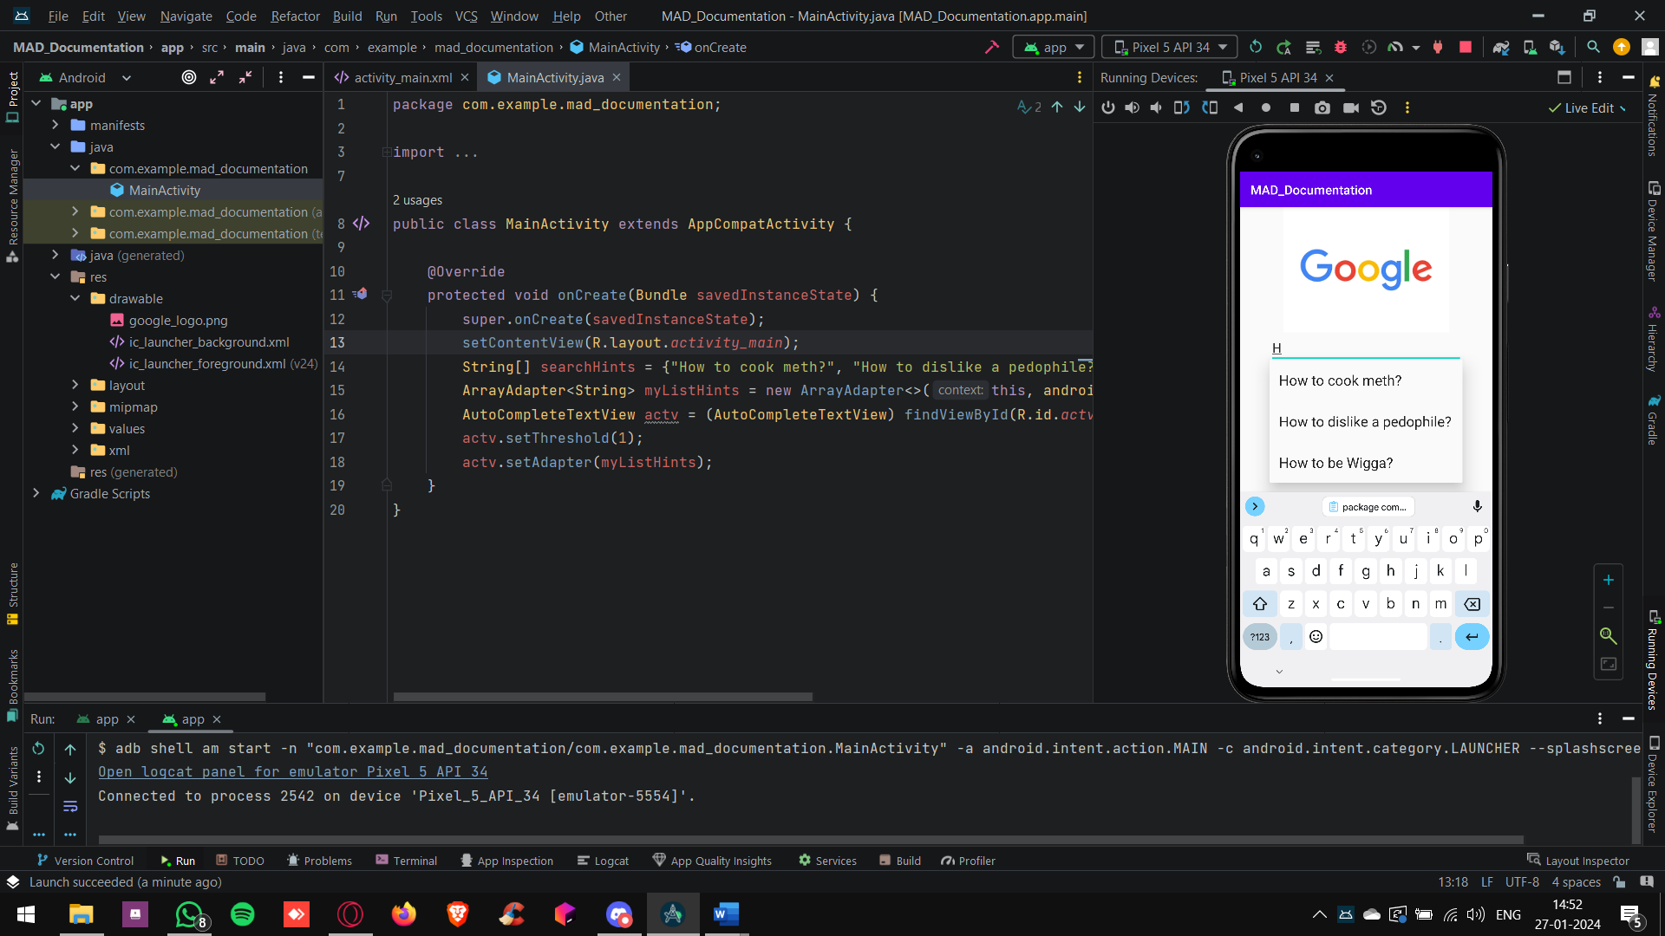

**2) Write a program to display all the Subjects of VI Semester using AutoCompleteTextView.**

**XML CODE:**

<?xml version="1.0" encoding="utf-8"?>  
<LinearLayout  
 xmlns:tools="http://schemas.android.com/tools" xmlns:android="http://schemas.android.com/apk/res/android" xmlns:app="http://schemas.android.com/apk/res-auto"  
 android:layout_width="match_parent"  
 android:layout_height="match_parent"  
 tools:context=".MainActivity"  
 android:orientation="vertical">  
 <ImageView  
 android:layout_width="wrap_content"  
 android:layout_height="wrap_content"  
 android:layout_gravity="center"  
 android:src="@drawable/google_logo"/>  
 <AutoCompleteTextView  
 android:layout_width="300dp"  
 android:layout_gravity="center"  
 android:layout_height="wrap_content"  
 android:completionThreshold="1"  
 android:id="@+id/actv"  
 android:textSize="20sp"  
 android:hint="Are you feeling lucky?"/>   
</LinearLayout>

**JAVA CODE:**

package com.example.mad_documentation;  
  
import android.support.v7.app.AppCompatActivity;  
import android.os.Bundle;  
import android.widget.ArrayAdapter;  
import android.widget.AutoCompleteTextView;  
  
public class MainActivity extends AppCompatActivity {  
  
 @Override  
 protected void onCreate(Bundle savedInstanceState) {  
 super.onCreate(savedInstanceState);  
 setContentView(R.layout.*activity_main*);  
 String[] searchHints = {"PHP", "PWP", "MAD", "EDE" ,"ETI" ,"MAD"};  
 ArrayAdapter<String> myListHints = new ArrayAdapter<>(this, android.R.layout.*select_dialog_item*, searchHints);  
 AutoCompleteTextView actv = (AutoCompleteTextView) findViewById(R.id.*actv*);  
 actv.setThreshold(1);  
 actv.setAdapter(myListHints);  
 }  
}

**OUTPUT:**

